Iho Lopez Tobi

il16d

Assignment #4

(max = 100)

Finish reading Chapter 1 in the *Computer Organization and Design* text (starting at page

1. … including Section 1.12 which is under Course Materials as **section_1.12.pdf**. Also, work through portions (B-3 through B-12 and B-26 through B-37) of Appendix B in the *Computer Organization and Design* text. Even though this is a relatively small amount of reading, it will take some time to learn how to use the Logisim software and to accomplish the tasks that I have set out for you. I have provided a set of notes (“Notes for Assignment #4) on this reading that can be found under Course Notes. Please refer to these notes as you carefully work through the assigned reading.

Afterwards, submit answers for the following problems (When appropriate, show your work! Some problems will require a little bit of algebra and the use of a scientific calculator.):

1. Do Exercise 1.12.1 on page 58 of the text. (3 points)

CPU Time 1= (CPI x Instruction count) / (clock rate )= (0.9x 5.0E9)/4.0E9=1.125

CPU Time 2= (CPI x Instruction count) / (clock rate )= (0.75x1.0E9)/3.0E9= 0.25

Performance 1/ Performance 2= CPU Time2/ CPU Time1= 0.25/1.125= 0.22

Processor 1 is 0.22 times slower than processor 2

Processor 1 has a larger clock rate than processor 2 so the statement is not true.

1. Do Exercise 1.12.3 on page 58 of the text. (3 points)

Processor 1.

Instruction count =1.0E9 CPI=0.9 Clock rate= 4.0E9

Processor 2.

Instruction count= x CPI=0.75 Clock rate= 3.0E9

CPU Time 1= (CPI x Instruction count) / (clock rate )= (0.9x 1.0E9)/4.0E9=0.225

CPU Time 1= CPU Time 2= 0.225

Instruction count 2 = CPU time x Clock rate/ CPI= (0.225 x 3.0E9)/0.75= 0.9E9

Processor 1 is executing a larger number of instructions than processor 2, but they both share the same CPU Time.

1. As you were working through the notes for this assignment, you should have created your own XOR circuit. It should have appropriate labels (including your name), similar to that shown in the notes. Show me a picture of your solution. In addition, submit **XOR.circ** as a separate file; the Mentor will clarify what I mean by this. (3 points)

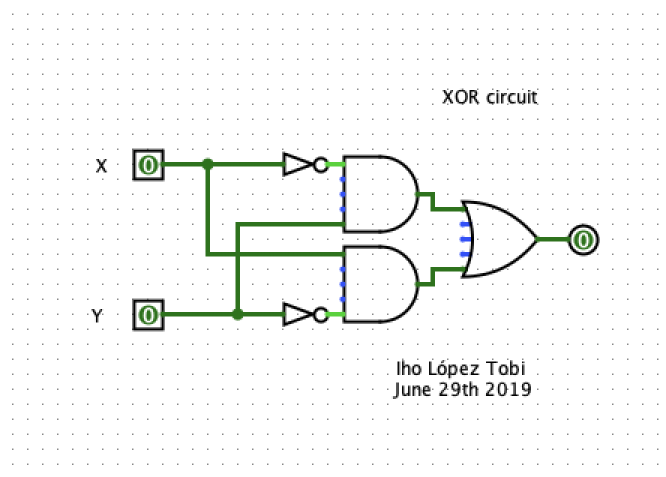

1. As you were working through the notes for this assignment, you should have created a 2:1 MUX; you should have then created a 4:1 MUX, using your 2:1 MUX as a subcircuit. Both of these circuits should have appropriate labels (including your name), similar to that shown in the notes. Show me a picture of your solution for each of these two circuits. In addition, submit **MUX.circ** as a separate file; the Mentor will clarify what I mean by this. (7 points)

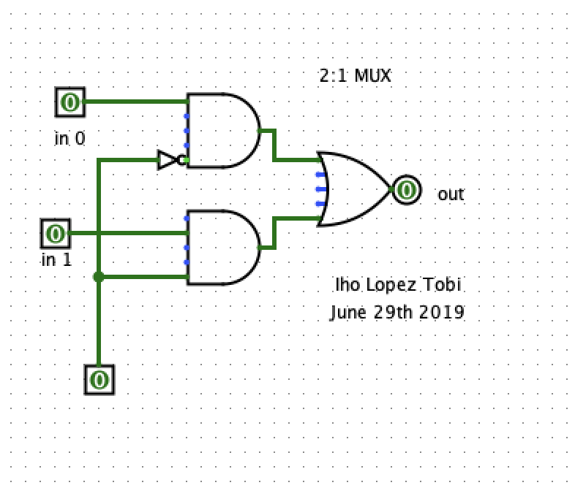

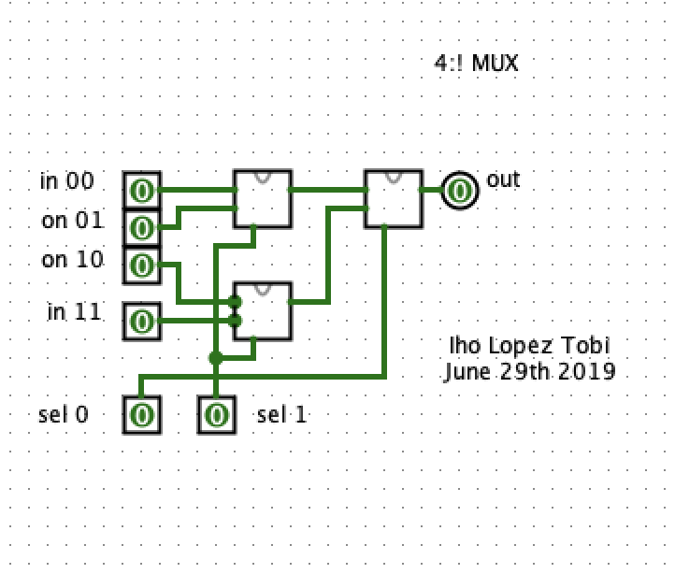

1. As you were working through the notes for this assignment, you should have created a 3-to-8 decoder with LED output. It should have appropriate labels (including your name), similar to that shown in the notes. Show me a picture of your decoder. In addition, submit **decoder.circ** as a separate file; the Mentor will clarify what I mean by this. ( 3 points)

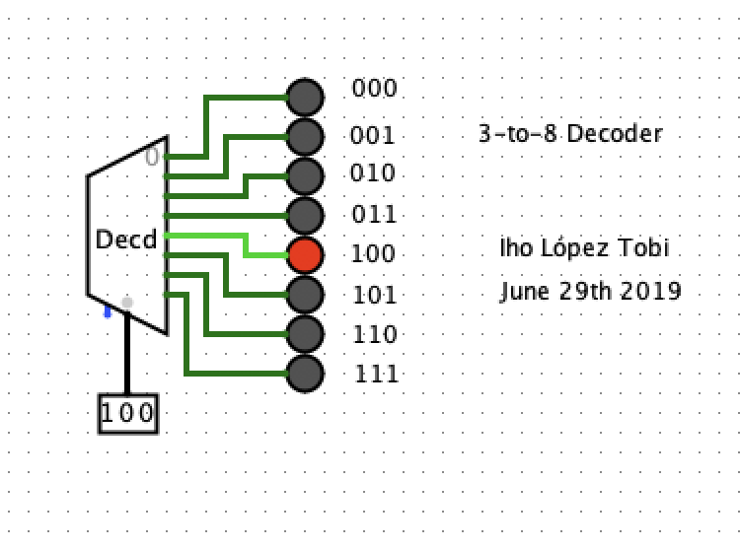

1. Start with the **ProductSumTest.circ** file that you constructed in the course notes. As you recall, this was used to verify the equivalence of the “sum of products” and “product of sums” representations for the logic function E (first discussed on page B-5). On page two of the course notes, I suggested two additional ways of representing this same logic function. I would like you to add these two suggestions to your **ProductSumTest.circ** file. I show my version of this expanded circuit at the top of the next page. Notice that I have used the predefined XOR, NAND, and XNOR gates that appear in the Gates library. NAND is just the “not” of an “AND”. XNOR is the “not” of an “XOR”; seems to me it should actually be named NXOR!

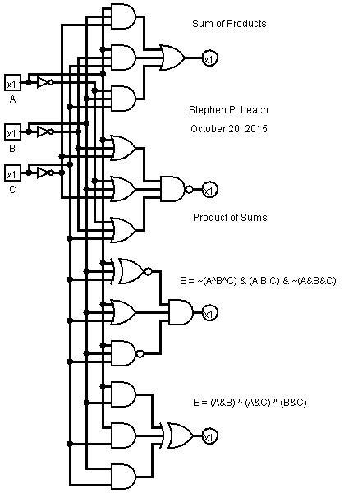

If you did this right, all four versions of E should produce the same output for all 8 input combinations of A, B and C. Your circuit should have appropriate labels (including your name), similar to that shown in the notes. Show me a picture of your enhanced circuit. In addition, submit your enhanced **ProductSumTest.circ** as a separate file; the Mentor will clarify what I mean by this. (16 points)

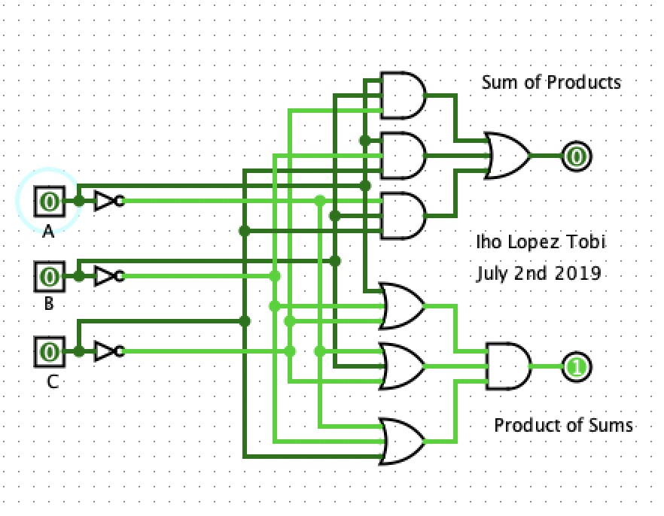

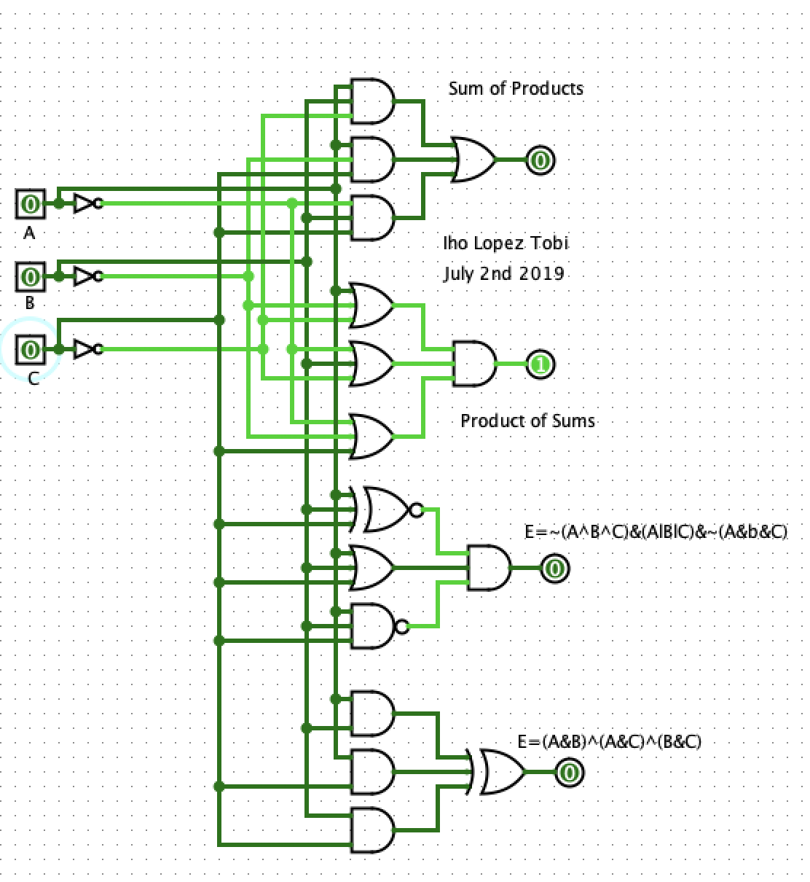

1. In the second half of the course notes we systematically constructed a fairly sophisticated 8-bit ALU. As part of that process, a number of circuits were produced. For each of the circuits indicated below, provide a picture of the one

that you constructed. In addition, submit your **Revised MUX.circ** and **ALU.circ** as separate files; the Mentor will clarify what I mean by this. (65 points total)

1. Revised 2:1 MUX (5 points)

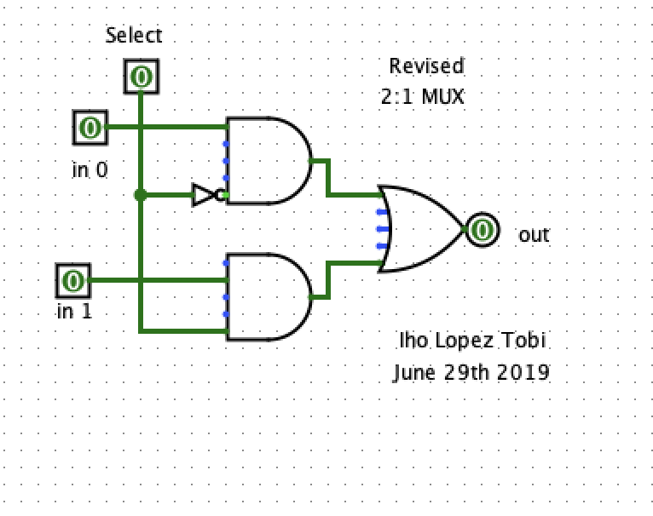

1. Revised 4:1 MUX (5 points)

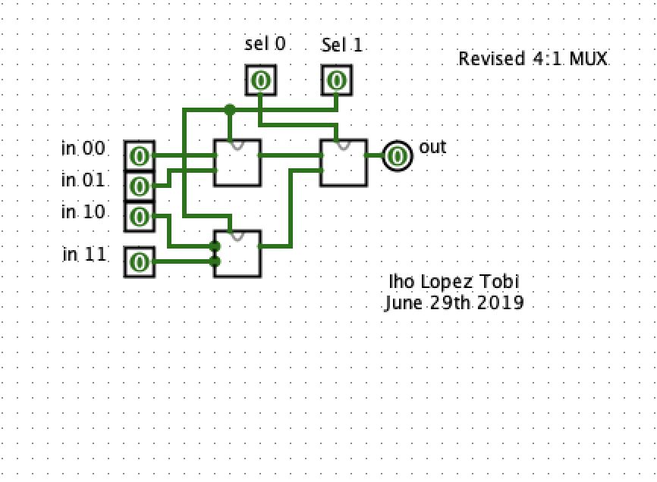

1. 1-Bit Adder (10 points)

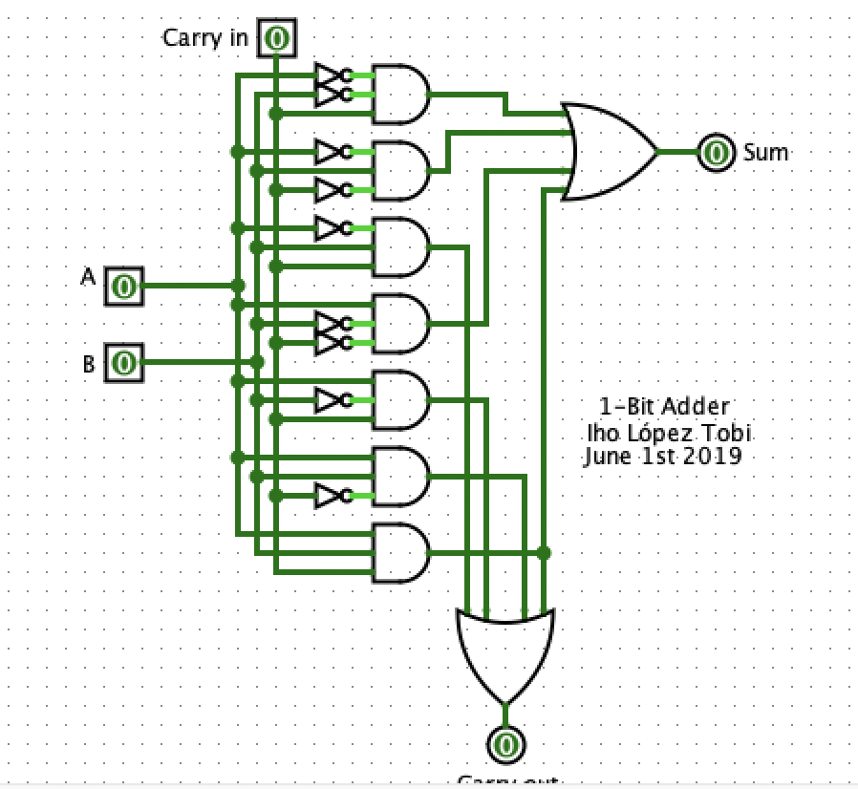

1. 1-Bit ALU Version 3 (10 points)

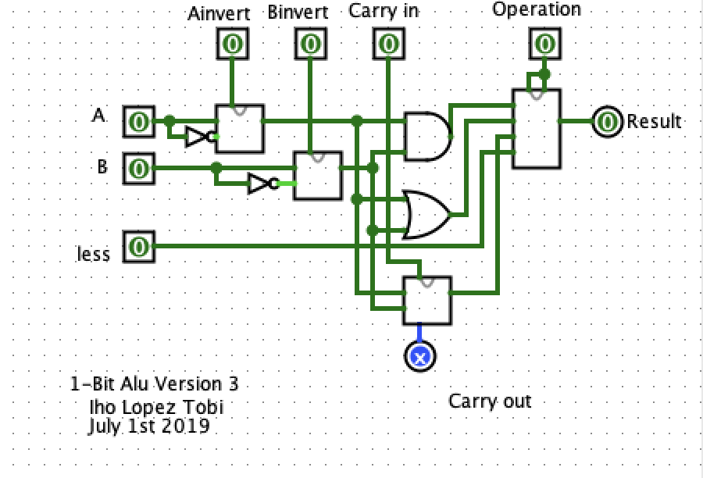

1. Top-Bit ALU (10 points)

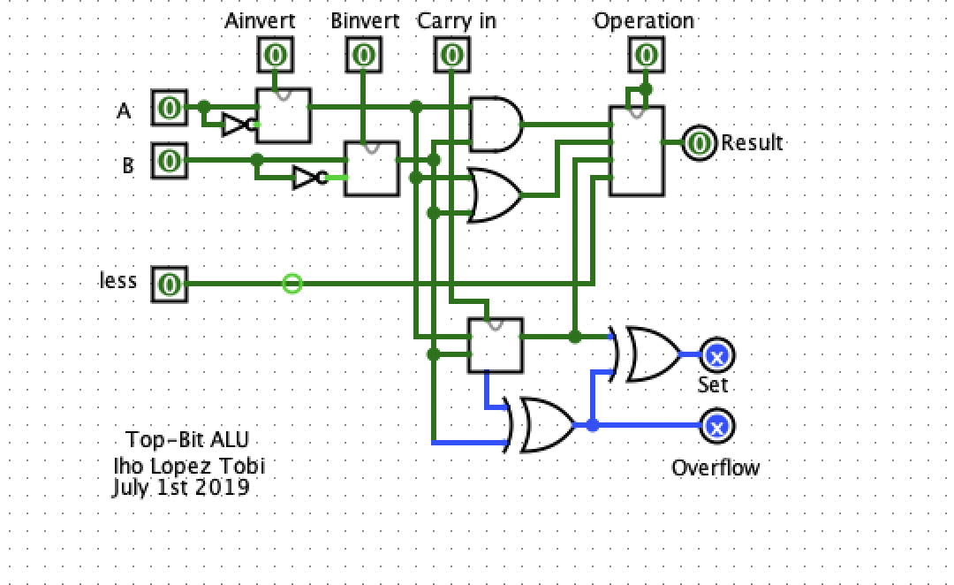

1. 8-Bit ALU Version 1 (20 points)

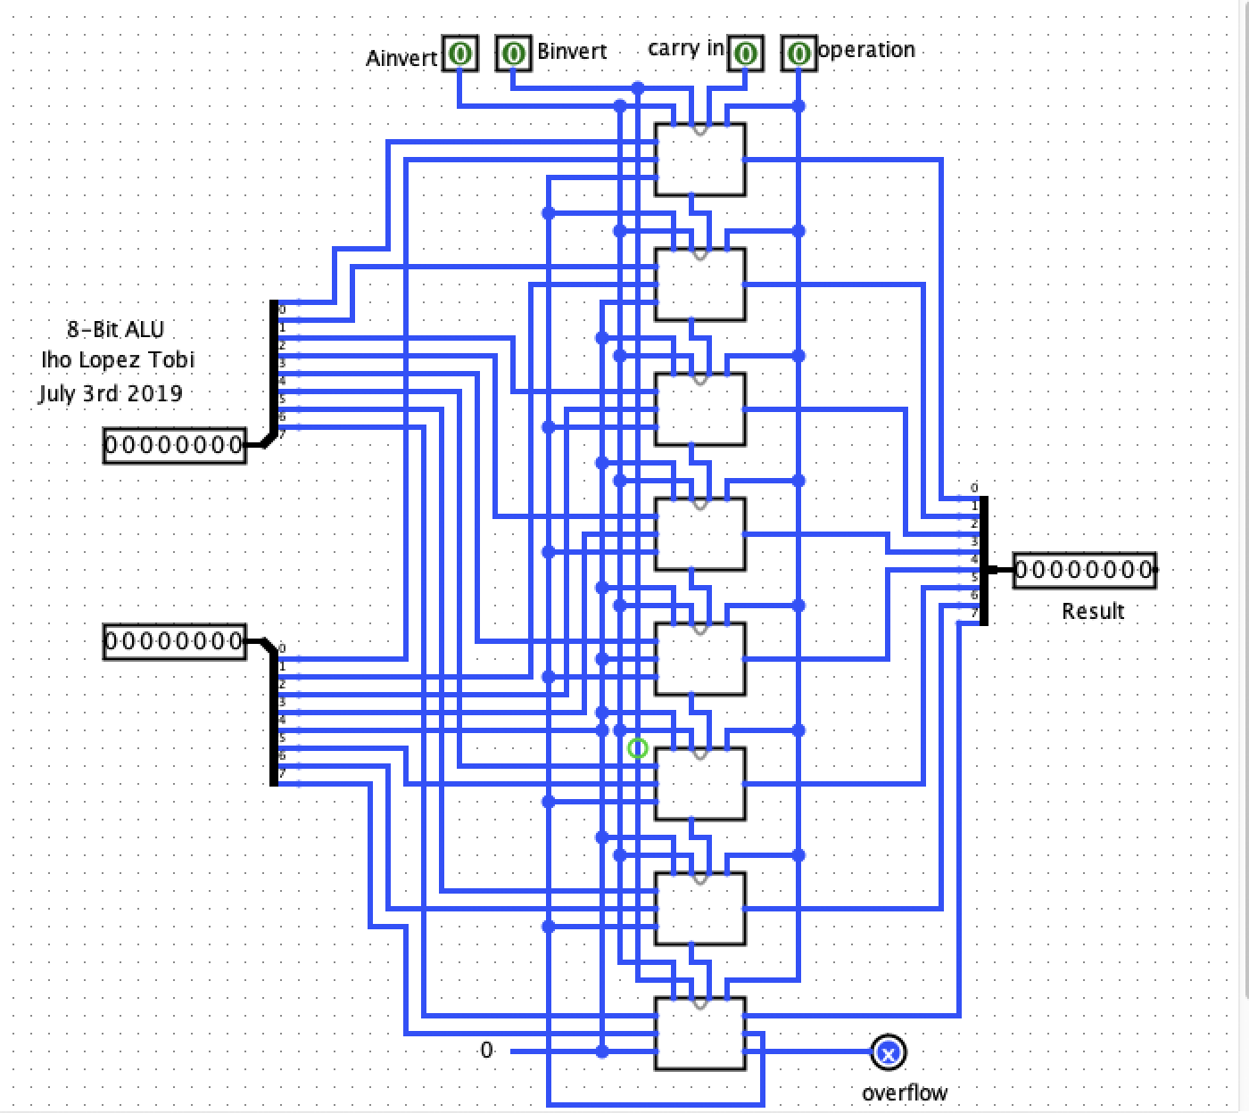

1. 8-Bit ALU Version 2 (5 points)

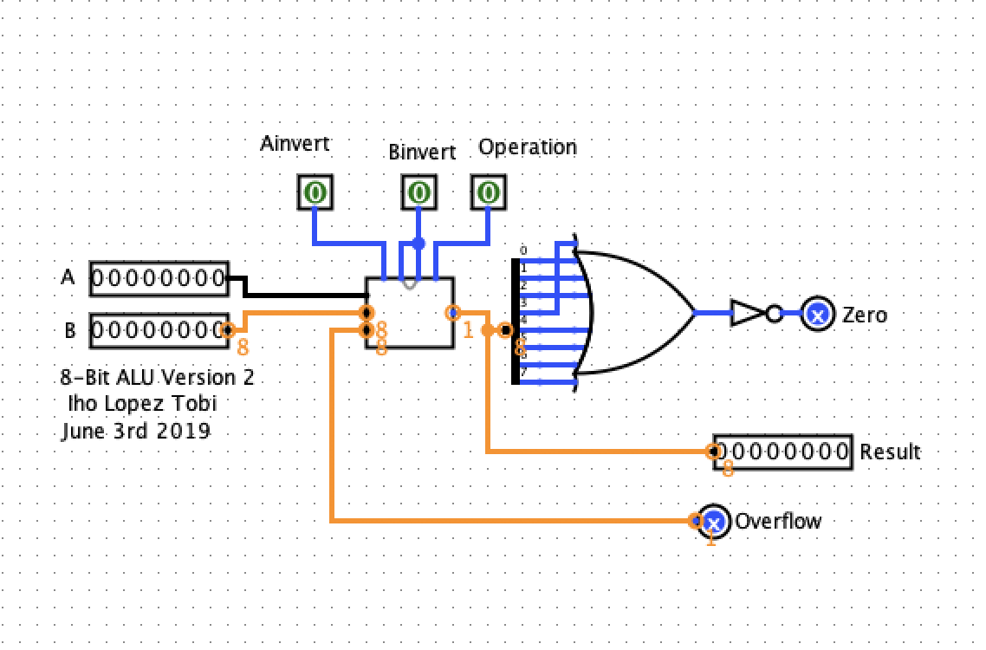

**Your assignment is due by 11:59 PM (Eastern Time) on the assignment due date (consult Course Calendar on course website).**